**DATA BASE MANAGEMENT SYSTEM**

**PROJECT**

**TITLE: e-Commerce Platform**

## INTRODUCTION

### Project Overview:

The **Java AWT-based eCommerce Platform** project aims to develop a scalable online store application using Java's Abstract Window Toolkit (AWT) for the frontend and JDBC (Java Database Connectivity) with MySQL for the backend. This project leverages Java's robust capabilities in GUI development and database management to create an interactive and efficient eCommerce platform.

### Project Goals:

The primary objectives of this project include:

* **GUI Development**: Implementing a user-friendly interface using Java AWT components such as frames, panels, buttons, text fields, and labels to facilitate user interaction.
* **Database Integration**: Utilizing JDBC to establish a seamless connection between the application and MySQL database for storing and retrieving data related to products, users, orders, and other eCommerce functionalities.
* **Functionality Implementation**: Enabling essential eCommerce features such as user authentication, product management (including adding, updating, and deleting products), shopping cart functionality, order processing, and order history tracking.
* **Scalability and Robustness**: Designing the application architecture to ensure scalability, robustness, and data integrity, thereby supporting potential future enhancements and increased user load.
* **User Experience Enhancement**: Prioritizing a smooth and intuitive user experience through thoughtful UI design and efficient backend operations.

### Technology Stack:

The technology stack for this project includes:

* **Java AWT**: Used for building the graphical user interface (GUI), providing essential components and layout management to create a responsive and visually appealing frontend.
* **JDBC (Java Database Connectivity)**: Employed for database interaction, enabling the application to connect to and manipulate data within a MySQL database management system.
* **MySQL**: Chosen as the relational database management system (RDBMS) to store and manage persistent data related to users, products, orders, and other eCommerce entities.

**ENTITIES**

1. **Registration:**

* **Attributes**:
  + rid (INT): Primary key, auto-incremented registration ID.
  + name (VARCHAR(45)): Name of the user.
  + pass (VARCHAR(45)): Password of the user.
  + email (VARCHAR(45)): Email address of the user.
  + phno (INT): Phone number of the user.
  + dob (DATE): Date of birth of the user.
  + address (VARCHAR(150)): Address of the user.
  + pin (INT): PIN code or postal code of the user.

1. **Products:**

* **Attributes**:
  + pid (INT): Primary key, auto-incremented product ID.
  + uid (INT): Foreign key referencing registration(rid), representing the user ID of the seller.
  + pname (VARCHAR(255)): Name of the product.
  + image (VARCHAR(500)): URL or path to the product image.
  + price (DECIMAL(10,2)): Price of the product.
  + category (VARCHAR(100)): Category or type of the product.
  + rating (INT): Rating of the product.

1. **Payments:**

* **Attributes**:
  + payment_id (INT): Primary key, auto-incremented payment ID.
  + uid (INT): Foreign key referencing registration(rid), representing the user ID making the payment.
  + payment_method (VARCHAR(50)): Payment method used (e.g., credit card, PayPal).
  + amount (DECIMAL(10, 2)): Amount paid.
  + payment_timestamp (TIMESTAMP): Timestamp indicating when the payment was made.

### RELATIONSHIPS

1. **Products and Registration (Seller Relationship)**:
   * **Foreign Key**: products.uid references registration.rid
   * **Description**: Each product (products) is associated with a seller (registration) identified by the uid field in the products table, which references the rid field in the registration table. This relationship ensures that each product is listed by a registered user.
   * **One-to-Many (1) Relationship**: Each seller (registered user) in registration can list multiple products in products, but each product is associated with only one seller.

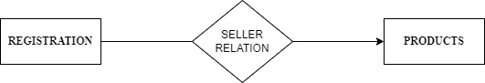

1. **Payments and Registration (User Payment Relationship)**:
   * **Foreign Key**: payments.uid references registration.rid
   * **Description**: Each payment (payments) made is associated with a user (registration) identified by the uid field in the payments table, which references the rid field in the registration table. This relationship ensures that each payment transaction is linked to a registered user who made the payment.
   * **Many-to-One (N:1) Relationship**: Each payment (payments) in the payments table is linked to exactly one user (registration) who made the payment, through the uid field.

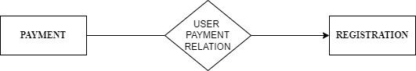

**E-R DIAGRAM**

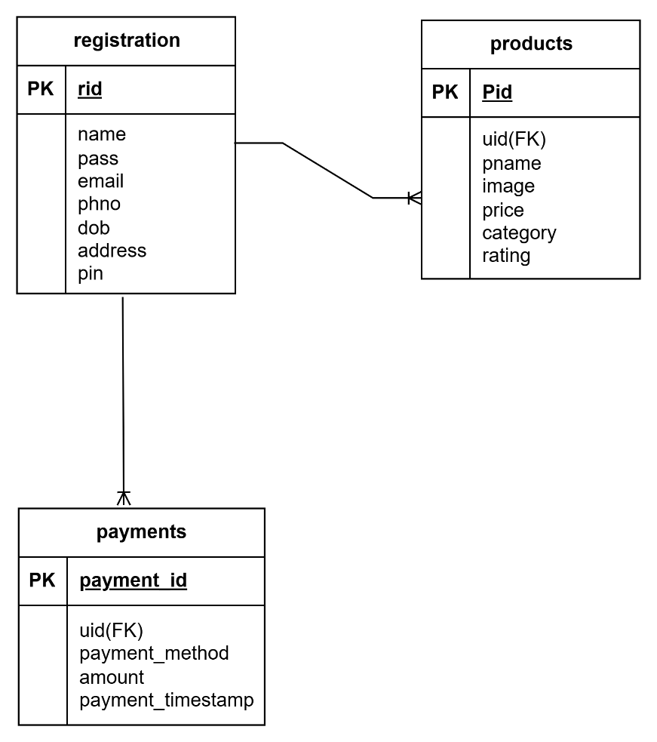

**SQL QUERIES:**

1. **Registration table:**

CREATE TABLE registration (

rid INT AUTO_INCREMENT PRIMARY KEY,

name VARCHAR(45) NOT NULL,

pass VARCHAR(45) NOT NULL,

email VARCHAR(45) NOT NULL,

phno INT NOT NULL,

dob DATE NOT NULL,

address VARCHAR(150) NOT NULL,

pin INT NOT NULL);

1. **Products table:**

CREATE TABLE products (

pid INT AUTO_INCREMENT PRIMARY KEY,

uid INT,

pname VARCHAR(255),

image VARCHAR(500),

price DECIMAL(10,2),

category VARCHAR(100),

rating INT,

FOREIGN KEY (uid) REFERENCES registration(rid)

);

1. **Payments table:**

CREATE TABLE payments (

payment_id INT AUTO_INCREMENT PRIMARY KEY,

uid INT,

payment_method VARCHAR(50) NOT NULL,

amount DECIMAL(10, 2) NOT NULL,

payment_timestamp TIMESTAMP DEFAULT CURRENT_TIMESTAMP,

FOREIGN KEY (uid) REFERENCES registration(rid)

);

**FRONTEND & BACKEND CODE:**

* **Registerform.java:**

import javax.imageio.ImageIO;

import javax.swing.*;

import java.awt.*;

import java.awt.event.ActionEvent;

import java.awt.event.ActionListener;

import java.io.File;

import java.io.IOException;

import java.sql.Connection;

import java.sql.Date;

import java.sql.DriverManager;

import java.sql.PreparedStatement;

import java.sql.SQLException;

public class registerform extends JFrame implements ActionListener {

private JTextField nameField, emailField, phNoField, dobField, addressField, pinField;

private JPasswordField passField;

private Image backgroundImage;

public registerform() {

setTitle("Registration Form");

setSize(500, 500);

setDefaultCloseOperation(JFrame.EXIT_ON_CLOSE);

setLayout(new BorderLayout());

try {

// Load background image using relative path (update path as per your image location)

backgroundImage = ImageIO.read(new File("src/cart.jpg"));

} catch (IOException e) {

e.printStackTrace();

}

BackgroundPanel bgPanel = new BackgroundPanel();

bgPanel.setLayout(new GridBagLayout());

bgPanel.setOpaque(false);

add(bgPanel, BorderLayout.CENTER);

GridBagConstraints gbc = new GridBagConstraints();

gbc.insets = new Insets(10, 10, 10, 10);

gbc.fill = GridBagConstraints.HORIZONTAL;

addLabelAndField(bgPanel, gbc, "Username:", nameField = new JTextField(15));

addLabelAndField(bgPanel, gbc, "Password:", passField = new JPasswordField(15));

addLabelAndField(bgPanel, gbc, "E-mail:", emailField = new JTextField(15));

addLabelAndField(bgPanel, gbc, "Ph no:", phNoField = new JTextField(15));

addLabelAndField(bgPanel, gbc, "DOB (yyyy-mm-dd):", dobField = new JTextField(15));

addLabelAndField(bgPanel, gbc, "Address:", addressField = new JTextField(15));

addLabelAndField(bgPanel, gbc, "Pin-code:", pinField = new JTextField(15));

JButton submitButton = new JButton("Submit");

submitButton.setFont(new Font("Arial", Font.BOLD, 14));

submitButton.setBackground(new Color(92, 159, 96));

submitButton.setForeground(Color.WHITE);

submitButton.addActionListener(this);

gbc.gridwidth = 2;

gbc.gridx = 0;

gbc.gridy++;

gbc.insets = new Insets(20, 10, 10, 10);

bgPanel.add(submitButton, gbc);

setLocationRelativeTo(null);

setVisible(true);

}

private void addLabelAndField(JPanel panel, GridBagConstraints gbc, String labelText, JTextField textField) {

gbc.gridwidth = 1;

gbc.gridx = 0;

gbc.gridy++;

JLabel label = new JLabel(labelText);

label.setFont(new Font("Arial", Font.BOLD, 16));

label.setForeground(Color.WHITE);

panel.add(label, gbc);

gbc.gridx = 1;

textField.setFont(new Font("Arial", Font.PLAIN, 16));

textField.setForeground(Color.BLACK); // Set the font color for the text field

textField.setBackground(new Color(255, 255, 255, 180)); // Set a semi-transparent white background

textField.setOpaque(true);

textField.setPreferredSize(new Dimension(200, 25)); // Set preferred size for larger text fields

panel.add(textField, gbc);

}

@Override

public void actionPerformed(ActionEvent e) {

if (e.getActionCommand().equals("Submit")) {

registerUser();

}}

private void registerUser() {

String name = nameField.getText();

String password = new String(passField.getPassword());

String email = emailField.getText();

String phNo = phNoField.getText();

String dob = dobField.getText();

String address = addressField.getText();

String pin = pinField.getText();

if (!isValidInput(name, password, email, phNo, dob, address, pin)) {

JOptionPane.showMessageDialog(this, "Invalid input. Please check your entries.", "Error", JOptionPane.ERROR_MESSAGE);

return;

}

try (Connection connection = DriverManager.getConnection(

"jdbc:mysql://localhost:3306/ecommerce", "root", "suvarna")) {

// Insert into registration table

String registrationQuery = "INSERT INTO registration(name, pass, email, phno, dob, address, pin) VALUES (?, ?, ?, ?, ?, ?, ?)";

PreparedStatement registrationPs = connection.prepareStatement(registrationQuery);

registrationPs.setString(1, name);

registrationPs.setString(2, password);

registrationPs.setString(3, email);

registrationPs.setInt(4, Integer.parseInt(phNo));

registrationPs.setDate(5, Date.valueOf(dob));

registrationPs.setString(6, address);

registrationPs.setInt(7, Integer.parseInt(pin));

int registrationRowsAffected = registrationPs.executeUpdate();

if (registrationRowsAffected > 0) {

JOptionPane.showMessageDialog(this, "Registered successfully", "Success", JOptionPane.INFORMATION_MESSAGE);

new Login(); // Open login window after successful registration

this.dispose();

} else {

JOptionPane.showMessageDialog(this, "Registration failed", "Error", JOptionPane.ERROR_MESSAGE);

}

registrationPs.close();

} catch (SQLException ex) {

ex.printStackTrace();

JOptionPane.showMessageDialog(this, "Registration failed. Please try again.", "Error", JOptionPane.ERROR_MESSAGE);

}}

private boolean isValidInput(String name, String password, String email, String phNo, String dob, String address, String pin) {

if (name.isEmpty() || password.isEmpty() || email.isEmpty() || phNo.isEmpty() || dob.isEmpty() || address.isEmpty() || pin.isEmpty()) {

return false;

}

try {

Integer.parseInt(phNo);

Integer.parseInt(pin);

Date.valueOf(dob);

} catch (Exception e) {

return false;

}

return true;

}

class BackgroundPanel extends JPanel {

@Override

protected void paintComponent(Graphics g) {

super.paintComponent(g);

if (backgroundImage != null) {

g.drawImage(backgroundImage, 0, 0, getWidth(), getHeight(), this);

}}}

public static void main(String[] args) {

SwingUtilities.invokeLater(registerform::new);

}}

**OUTPUT:**

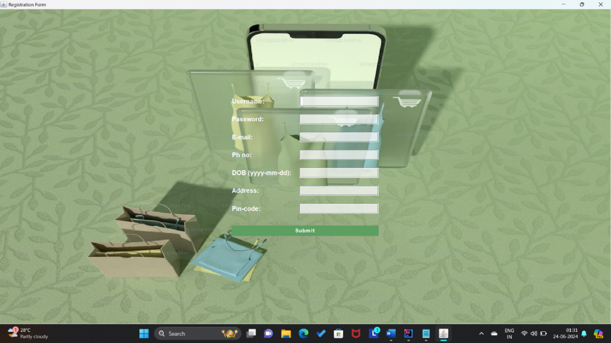

* **Login.java:**

import javax.imageio.ImageIO;

import javax.swing.*;

import java.awt.*;

import java.awt.event.ActionEvent;

import java.awt.event.ActionListener;

import java.io.File;

import java.io.IOException;

import java.sql.Connection;

import java.sql.DriverManager;

import java.sql.PreparedStatement;

import java.sql.ResultSet;

import java.sql.SQLException;

public class Login extends JFrame implements ActionListener {

private JTextField t_us;

private JPasswordField t_pas;

private JLabel usernameLabel;

private JLabel passwordLabel;

private JButton submit;

private JButton signup_but;

private JLabel message;

private Image backgroundImage;

public Login() {

setTitle("Smart Cart Login");

try {

backgroundImage = ImageIO.read(new File("src/smart.jpg"));// Load background image

} catch (IOException e) {

e.printStackTrace();

}

BackgroundPanel bgPanel = new BackgroundPanel(); // Create panel with background image

bgPanel.setLayout(new GridBagLayout());

add(bgPanel);

GridBagConstraints gbc = new GridBagConstraints();

gbc.insets = new Insets(10, 10, 10, 10);

JLabel headlineLabel = new JLabel("LOGIN"); // Create headline label

headlineLabel.setFont(new Font("Arial", Font.BOLD, 18));

headlineLabel.setForeground(Color.WHITE);

gbc.gridwidth = 2;

gbc.gridx = 0;

gbc.gridy = 0;

bgPanel.add(headlineLabel, gbc);

usernameLabel = new JLabel("Username:"); // Create username label and field

usernameLabel.setFont(new Font("Arial", Font.BOLD, 14));

usernameLabel.setForeground(Color.WHITE);

gbc.gridwidth = 1;

gbc.gridx = 0;

gbc.gridy = 1;

bgPanel.add(usernameLabel, gbc);

t_us = new JTextField(15);

t_us.setFont(new Font("Arial", Font.PLAIN, 14));

t_us.setPreferredSize(new Dimension(200, 25));

gbc.gridx = 1;

gbc.gridy = 1;

bgPanel.add(t_us, gbc);

passwordLabel = new JLabel("Password:"); // Create password label and field

passwordLabel.setFont(new Font("Arial", Font.BOLD, 14));

passwordLabel.setForeground(Color.WHITE);

gbc.gridx = 0;

gbc.gridy = 2;

bgPanel.add(passwordLabel, gbc);

t_pas = new JPasswordField(15);

t_pas.setFont(new Font("Arial", Font.PLAIN, 14));

t_pas.setPreferredSize(new Dimension(200, 25));

gbc.gridx = 1;

gbc.gridy = 2;

bgPanel.add(t_pas, gbc);

submit = new JButton("Sign in"); // Create submit button

submit.setFont(new Font("Arial", Font.BOLD, 14));

submit.setBackground(Color.BLUE);

submit.setForeground(Color.WHITE);

gbc.gridwidth = 2;

gbc.gridx = 0;

gbc.gridy = 3;

bgPanel.add(submit, gbc);

submit.addActionListener(this);

message = new JLabel("Don't have an account?"); // Create signup button and message

message.setFont(new Font("Arial", Font.PLAIN, 16));

message.setForeground(Color.WHITE);

gbc.gridwidth = 1;

gbc.gridx = 0;

gbc.gridy = 4;

bgPanel.add(message, gbc);

signup_but = new JButton("Sign Up");

signup_but.setFont(new Font("Arial", Font.BOLD, 14));

signup_but.setBackground(Color.GREEN);

signup_but.setForeground(Color.WHITE);

gbc.gridx = 1;

gbc.gridy = 4;

bgPanel.add(signup_but, gbc);

signup_but.addActionListener(this);

setDefaultCloseOperation(EXIT_ON_CLOSE);

setSize(500, 500);

setLocationRelativeTo(null);

setVisible(true);

}

@Override

public void actionPerformed(ActionEvent e) {

if (e.getSource() == submit) {

String user = t_us.getText();

String pass = new String(t_pas.getPassword());

try {

Connection con = DriverManager.getConnection("jdbc:mysql://localhost:3306/ecommerce", "root", "suvarna");

String query = "SELECT rid FROM registration WHERE name = ? AND pass = ?";

PreparedStatement ps = con.prepareStatement(query);

ps.setString(1, user);

ps.setString(2, pass);

ResultSet rs = ps.executeQuery();

if (rs.next()) {

int userId = rs.getInt("rid"); // Retrieve userId

JOptionPane.showMessageDialog(this, "Login Successful", "Success", JOptionPane.INFORMATION_MESSAGE);

openUserDashboard(userId); // Open UserDashboard with userId

this.dispose();

} else {

JOptionPane.showMessageDialog(this, "Invalid username or password!", "Error", JOptionPane.ERROR_MESSAGE);

}

rs.close();

ps.close();

con.close();

} catch (SQLException e1) {

e1.printStackTrace();

JOptionPane.showMessageDialog(this, "An error occurred. Please try again later.", "Error", JOptionPane.ERROR_MESSAGE);

}

} else if (e.getSource() == signup_but) {

new registerform();

this.dispose();

} }

private void openUserDashboard(int userId) {

SwingUtilities.invokeLater(() -> {

UserDashboard userDashboard = new UserDashboard(userId);

userDashboard.setVisible(true);

}); }

class BackgroundPanel extends JPanel {

@Override

protected void paintComponent(Graphics g) {

super.paintComponent(g);

if (backgroundImage != null) {

g.drawImage(backgroundImage, 0, 0, getWidth(), getHeight(), this);

}}}

public static void main(String[] args) {

SwingUtilities.invokeLater(Login::new);

}}

**OUTPUT:**

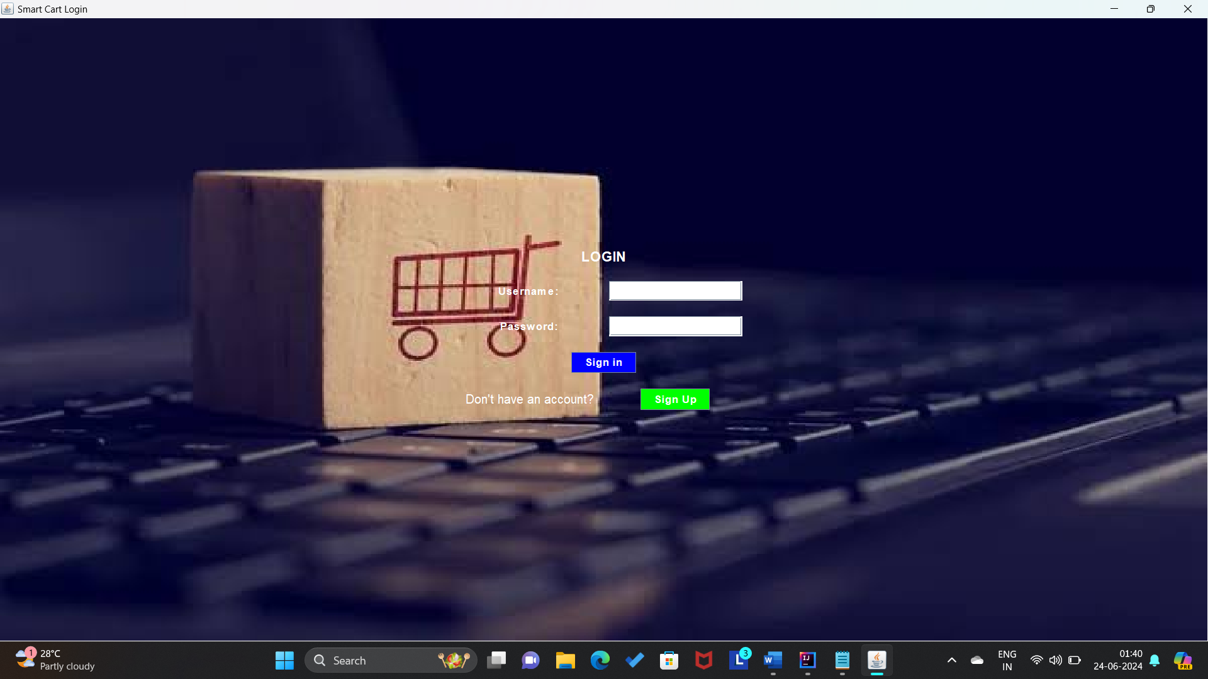

* **UserDashboard.java:**

import javax.swing.*;

import java.awt.*;

import java.awt.event.ActionEvent;

import java.awt.event.ActionListener;

import java.io.IOException;

import java.net.URL;

import java.sql.*;

import java.util.ArrayList;

import java.util.List;

public class UserDashboard extends JFrame {

private JTextArea cartTextArea;

private double totalAmount;

private JLabel totalLabel;

private List<Product> productList;

private int userId;

// JDBC URL, username, and password of MySQL server

private static final String JDBC_URL = "jdbc:mysql://localhost:3306/ecommerce";

private static final String USERNAME = "root";

private static final String PASSWORD = "suvarna";

// SQL queries for product management

private static final String INSERT_PRODUCT_SQL = "INSERT INTO products (pname, image, price, category, rating) VALUES (?, ?, ?, ?, ?)";

private static final String UPDATE_PRODUCT_SQL = "UPDATE products SET pname = ?, image = ?, price = ?, category = ?, rating = ? WHERE pid = ?";

private static final String DELETE_PRODUCT_SQL = "DELETE FROM products WHERE pid = ?";

public UserDashboard(int userId) {

this.userId=userId;

setTitle("SMART MART");

setDefaultCloseOperation(JFrame.EXIT_ON_CLOSE);

setSize(800, 600);

setLocationRelativeTo(null);

productList = new ArrayList<>();

cartTextArea = new JTextArea(10, 30);

// Load products from the database

loadProductsFromDatabase();

JPanel mainPanel = new JPanel(new BorderLayout(10, 10));

add(mainPanel);

JPanel headerPanel = new JPanel();

headerPanel.setBackground(new Color(32, 178, 170));

mainPanel.add(headerPanel, BorderLayout.NORTH);

JLabel titleLabel = new JLabel("SMART MART products");

titleLabel.setFont(new Font("Arial", Font.BOLD, 24));

headerPanel.add(titleLabel);

JPanel contentPanel = new JPanel(new BorderLayout(10, 10));

mainPanel.add(contentPanel, BorderLayout.CENTER);

// Create and add the categories combo box

JPanel categoryPanel = new JPanel();

categoryPanel.setBackground(new Color(244, 194, 194));

JLabel categoryLabel = new JLabel("Category:");

categoryLabel.setFont(new Font("Arial", Font.BOLD, 20));

JComboBox<String> categoryComboBox = new JComboBox<>();

categoryComboBox.addItem("All");

categoryComboBox.addItem("Electronics");

categoryComboBox.addItem("Clothing");

categoryComboBox.addItem("Books");

categoryComboBox.addItem("Home Decor");

categoryPanel.add(categoryLabel);

categoryPanel.add(categoryComboBox);

contentPanel.add(categoryPanel, BorderLayout.NORTH);

JScrollPane scrollPane = new JScrollPane();

contentPanel.add(scrollPane, BorderLayout.CENTER);

JPanel productsPanel = new JPanel(new GridLayout(0, 4, 10, 10));

productsPanel.setBorder(BorderFactory.createTitledBorder("Products"));

productsPanel.setBackground(new Color(245, 245, 176));

scrollPane.setViewportView(productsPanel);

updateProductPanel(productsPanel, "All");

// Bottom panel with buttons

JPanel bottomPanel = new JPanel(new FlowLayout(FlowLayout.CENTER));

JButton resetButton = new JButton("Reset");

JPanel resetPanel = new JPanel(new FlowLayout(FlowLayout.LEFT));

bottomPanel.add(resetPanel, BorderLayout.WEST);

resetButton.addActionListener(new ActionListener() {

@Override

public void actionPerformed(ActionEvent e) {

resetCart();

}

});

resetPanel.add(resetButton);

JButton checkoutButton = new JButton("Checkout");

checkoutButton.addActionListener(new ActionListener() {

@Override

public void actionPerformed(ActionEvent e) {

if (totalAmount == 0.0) {

JOptionPane.showMessageDialog(UserDashboard.this, "Please select products before checkout.");

} else {

JOptionPane.showMessageDialog(UserDashboard.this, "Checkout complete!");

BillingDashboard billingDashboard = new BillingDashboard(UserDashboard.this);

billingDashboard.setVisible(true);

}

}

});

JButton insertButton = new JButton("Insert Product");

insertButton.addActionListener(new ActionListener() {

@Override

public void actionPerformed(ActionEvent e) {

// Call a method to handle inserting a new product

insertProductDialog();

}

});

JButton deleteButton = new JButton("Delete Product");

deleteButton.addActionListener(new ActionListener() {

@Override

public void actionPerformed(ActionEvent e) {

// Call a method to handle deleting a product

deleteProductDialog();

}

});

JButton updateButton = new JButton("Update Product");

updateButton.addActionListener(new ActionListener() {

@Override

public void actionPerformed(ActionEvent e) {

// Call a method to handle updating a product

updateProductDialog();

}

});

bottomPanel.setBackground(new Color(32, 178, 170));

bottomPanel.add(insertButton);

bottomPanel.add(updateButton);

bottomPanel.add(deleteButton);

bottomPanel.add(checkoutButton);

mainPanel.add(bottomPanel, BorderLayout.SOUTH);

categoryComboBox.addActionListener(new ActionListener() {

@Override

public void actionPerformed(ActionEvent e) {

String selectedCategory = (String) categoryComboBox.getSelectedItem();

updateProductPanel(productsPanel, selectedCategory);

}

});

JPanel cartPanel = new JPanel(new BorderLayout());

cartPanel.setBorder(BorderFactory.createTitledBorder("Cart"));

cartPanel.setBackground(new Color(181, 235, 255));

mainPanel.add(cartPanel, BorderLayout.EAST);

JLabel cartLabel = new JLabel("Cart");

cartLabel.setFont(new Font("Arial", Font.BOLD, 18));

cartPanel.add(cartLabel, BorderLayout.NORTH);

cartTextArea = new JTextArea(10, 10);

cartTextArea.setEditable(false);

cartTextArea.setFont(new Font("Arial", Font.PLAIN, 15)); // Set the font size

JScrollPane cartScrollPane = new JScrollPane(cartTextArea);

cartPanel.add(cartScrollPane, BorderLayout.CENTER);

totalLabel = new JLabel("Total Amount: ₹0.00");

totalLabel.setFont(new Font("Arial", Font.BOLD, 18));

cartPanel.add(totalLabel, BorderLayout.SOUTH);

}

private void loadProductsFromDatabase() {

try (Connection connection = DriverManager.getConnection(JDBC_URL, USERNAME, PASSWORD)) {

String query = "SELECT * FROM products";

try (PreparedStatement preparedStatement = connection.prepareStatement(query)) {

ResultSet resultSet = preparedStatement.executeQuery();

while (resultSet.next()) {

String productName = resultSet.getString("pname");

String imagePath = resultSet.getString("image");

String price = resultSet.getString("price");

double amount = resultSet.getDouble("price");

String category = resultSet.getString("category");

int rating = resultSet.getInt("rating"); // Retrieve rating from the result set

productList.add(new Product(productName, imagePath, price, amount, category, rating)); // Pass rating to Product constructor

}

}

} catch (SQLException e) {

e.printStackTrace();

}

}

private void updateProductPanel(JPanel productsPanel, String selectedCategory) {

productsPanel.removeAll();

JPanel productContainer = new JPanel(new GridLayout(0, 4, 10, 10));

// Iterate over the products and add only those matching the selected category

for (Product product : productList) {

if (selectedCategory.equals("All") || product.getCategory().equals(selectedCategory)) {

addProductPanel(productContainer, product);

}

}

JScrollPane scrollPane = new JScrollPane(productContainer);

scrollPane.setVerticalScrollBarPolicy(JScrollPane.VERTICAL_SCROLLBAR_ALWAYS);

productsPanel.add(scrollPane, BorderLayout.CENTER);

// Refresh the panel

productsPanel.revalidate();

productsPanel.repaint();

}

public void resetCart() {

cartTextArea.setText("");

totalAmount = 0.0;

totalLabel.setText("Total Amount: ₹0.00");

}

private void addProductPanel(JPanel productsPanel, Product product) {

try {

// Load image from URL

ImageIcon productImage = new ImageIcon(new URL(product.getImagePath()));

Image scaledProductImage = productImage.getImage().getScaledInstance(110, 110, Image.SCALE_SMOOTH);

JPanel productPanel = new JPanel(new GridBagLayout());

productPanel.setPreferredSize(new Dimension(315, 250)); // Adjusted size to accommodate image

productPanel.setBorder(BorderFactory.createLineBorder(Color.BLACK));

JLabel imageLabel = new JLabel(new ImageIcon(scaledProductImage));

GridBagConstraints gbc = new GridBagConstraints();

gbc.gridx = 0;

gbc.gridy = 0;

gbc.gridwidth = 2;

gbc.fill = GridBagConstraints.BOTH;

gbc.anchor = GridBagConstraints.CENTER;

gbc.insets = new Insets(0, 0, 10, 0);

productPanel.add(imageLabel, gbc);

JLabel nameLabel = new JLabel(product.getProductName());

nameLabel.setFont(new Font("Arial", Font.BOLD, 18)); // Increase font size

gbc = new GridBagConstraints();

gbc.gridx = 0;

gbc.gridy = 1;

gbc.gridwidth = 2;

gbc.fill = GridBagConstraints.HORIZONTAL;

gbc.anchor = GridBagConstraints.CENTER;

gbc.insets = new Insets(0, 0, 5, 0);

productPanel.add(nameLabel, gbc);

JLabel priceLabel = new JLabel(product.getPrice());

priceLabel.setFont(new Font("Arial", Font.PLAIN, 18)); // Increase font size

gbc = new GridBagConstraints();

gbc.gridx = 0;

gbc.gridy = 2;

gbc.gridwidth = 2;

gbc.fill = GridBagConstraints.HORIZONTAL;

gbc.anchor = GridBagConstraints.CENTER;

gbc.insets = new Insets(0, 0, 5, 0);

productPanel.add(priceLabel, gbc);

JLabel ratingLabel = new JLabel("Rating: " + product.getRating()); // Add JLabel for displaying rating

ratingLabel.setFont(new Font("Arial", Font.PLAIN, 18)); // Increase font size

gbc = new GridBagConstraints();

gbc.gridx = 0;

gbc.gridy = 3;

gbc.gridwidth = 2;

gbc.fill = GridBagConstraints.HORIZONTAL;

gbc.anchor = GridBagConstraints.CENTER;

gbc.insets = new Insets(0, 0, 5, 0);

productPanel.add(ratingLabel, gbc);

JButton addToCartButton = new JButton("Add to Cart");

addToCartButton.setFont(new Font("Arial", Font.PLAIN, 18)); // Increase font size

gbc = new GridBagConstraints();

gbc.gridx = 0;

gbc.gridy = 4;

gbc.gridwidth = 2;

gbc.fill = GridBagConstraints.HORIZONTAL;

gbc.anchor = GridBagConstraints.CENTER;

productPanel.add(addToCartButton, gbc);

addToCartButton.addActionListener(new ActionListener() {

@Override

public void actionPerformed(ActionEvent e) {

String cartItem = product.getProductName() + " - " + product.getPrice();

cartTextArea.append(cartItem + "\n");

totalAmount += product.getAmount();

totalLabel.setText(String.format("Total Amount: ₹%.2f", totalAmount));

}

});

productsPanel.add(productPanel);

} catch (IOException e) {

e.printStackTrace();

}

}

// Method to handle inserting a new product

private void insertProductDialog() {

// Create dialog components

JTextField nameField = new JTextField(10);

JTextField imageField = new JTextField(10);

JTextField priceField = new JTextField(10);

JTextField categoryField = new JTextField(10);

JTextField ratingField = new JTextField(10);

JPanel panel = new JPanel(new GridLayout(0, 1));

panel.add(new JLabel("Name:"));

panel.add(nameField);

panel.add(new JLabel("Image URL:"));

panel.add(imageField);

panel.add(new JLabel("Price:"));

panel.add(priceField);

panel.add(new JLabel("Category:"));

panel.add(categoryField);

panel.add(new JLabel("Rating:"));

panel.add(ratingField);

int result = JOptionPane.showConfirmDialog(null, panel, "Insert Product", JOptionPane.OK_CANCEL_OPTION);

if (result == JOptionPane.OK_OPTION) {

try (Connection connection = DriverManager.getConnection(JDBC_URL, USERNAME, PASSWORD);

PreparedStatement preparedStatement = connection.prepareStatement(INSERT_PRODUCT_SQL)) {

preparedStatement.setString(1, nameField.getText());

preparedStatement.setString(2, imageField.getText());

preparedStatement.setDouble(3, Double.parseDouble(priceField.getText()));

preparedStatement.setString(4, categoryField.getText());

preparedStatement.setInt(5, Integer.parseInt(ratingField.getText()));

preparedStatement.executeUpdate();

JOptionPane.showMessageDialog(null, "Product inserted successfully.");

} catch (SQLException e) {

JOptionPane.showMessageDialog(null, "Error: " + e.getMessage(), "Error", JOptionPane.ERROR_MESSAGE);

}

}

}

// Method to handle updating an existing product

private void updateProductDialog() {

// Create dialog components

JTextField idField = new JTextField(5);

JTextField nameField = new JTextField(10);

JTextField imageField = new JTextField(10);

JTextField priceField = new JTextField(10);

JTextField categoryField = new JTextField(10);

JTextField ratingField = new JTextField(10);

JPanel panel = new JPanel(new GridLayout(0, 1));

panel.add(new JLabel("Product ID:"));

panel.add(idField);

panel.add(new JLabel("Name:"));

panel.add(nameField);

panel.add(new JLabel("Image URL:"));

panel.add(imageField);

panel.add(new JLabel("Price:"));

panel.add(priceField);

panel.add(new JLabel("Category:"));

panel.add(categoryField);

panel.add(new JLabel("Rating:"));

panel.add(ratingField);

int result = JOptionPane.showConfirmDialog(null, panel, "Update Product", JOptionPane.OK_CANCEL_OPTION);

if (result == JOptionPane.OK_OPTION) {

try (Connection connection = DriverManager.getConnection(JDBC_URL, USERNAME, PASSWORD);

PreparedStatement preparedStatement = connection.prepareStatement(UPDATE_PRODUCT_SQL)) {

preparedStatement.setString(1, nameField.getText());

preparedStatement.setString(2, imageField.getText());

preparedStatement.setDouble(3, Double.parseDouble(priceField.getText()));

preparedStatement.setString(4, categoryField.getText());

preparedStatement.setInt(5, Integer.parseInt(ratingField.getText()));

preparedStatement.setInt(6, Integer.parseInt(idField.getText()));

int rowsAffected = preparedStatement.executeUpdate();

if (rowsAffected > 0) {

JOptionPane.showMessageDialog(null, "Product updated successfully.");

} else {

JOptionPane.showMessageDialog(null, "Failed to update product. Product ID not found.", "Error", JOptionPane.ERROR_MESSAGE);

}

} catch (SQLException e) {

JOptionPane.showMessageDialog(null, "Error: " + e.getMessage(), "Error", JOptionPane.ERROR_MESSAGE);

}

}

}

// Method to handle deleting an existing product

private void deleteProductDialog() {

JTextField idField = new JTextField(5);

JPanel panel = new JPanel(new GridLayout(0, 1));

panel.add(new JLabel("Product ID:"));

panel.add(idField);

int result = JOptionPane.showConfirmDialog(null, panel, "Delete Product", JOptionPane.OK_CANCEL_OPTION);

if (result == JOptionPane.OK_OPTION) {

try (Connection connection = DriverManager.getConnection(JDBC_URL, USERNAME, PASSWORD);

PreparedStatement preparedStatement = connection.prepareStatement(DELETE_PRODUCT_SQL)) {

preparedStatement.setInt(1, Integer.parseInt(idField.getText()));

int rowsAffected = preparedStatement.executeUpdate();

if (rowsAffected > 0) {

JOptionPane.showMessageDialog(null, "Product deleted successfully.");

} else {

JOptionPane.showMessageDialog(null, "Failed to delete product. Product ID not found.", "Error", JOptionPane.ERROR_MESSAGE);

}

} catch (SQLException e) {

JOptionPane.showMessageDialog(null, "Error: " + e.getMessage(), "Error", JOptionPane.ERROR_MESSAGE);

}

}

}

public JTextArea getCartTextArea() {

return cartTextArea;

}

public double getTotalAmount() {

return totalAmount;

}

public List<Product> getProductList(){

return productList;

}

public int getUid() {

return userId;

}

// Inner Product class definition

public class Product {

private String productName;

private String imagePath;

private String price;

private double amount;

private String category;

private int rating;

public Product(String productName, String imagePath, String price, double amount, String category, int rating) {

this.productName = productName;

this.imagePath = imagePath;

this.price = price;

this.amount = amount;

this.category = category;

this.rating = rating;

}

public String getProductName() {

return productName;

}

public String getImagePath() {

return imagePath;

}

public String getPrice() {

return price;

}

public double getAmount() {

return amount;

}

public String getCategory() {

return category;

}

public int getRating() {

return rating;

}

}

public void run() {

SwingUtilities.invokeLater(new Runnable() {

public void run() {

new UserDashboard(userId);

} }); }

public static void main(String[] args) {

SwingUtilities.invokeLater(new Runnable() {

public void run() {

// Simulate a login scenario (replace with actual login/authentication logic)

String username = JOptionPane.showInputDialog("Enter username:");

String password = JOptionPane.showInputDialog("Enter password:");

// Example of checking username and password (replace with your authentication logic)

int userId = authenticateUser(username, password);

if (userId != -1) {

UserDashboard userDashboard = new UserDashboard(userId);

userDashboard.setVisible(true);

} else {

JOptionPane.showMessageDialog(null, "Invalid username or password. Exiting...");

System.exit(0); // Exit application if authentication fails

} }); }

private static int authenticateUser(String username, String password) {

int userId = -1; // Initialize userId to -1 (or any default value indicating failure)

// Example logic to authenticate user (replace with your actual authentication mechanism)

try (Connection connection = DriverManager.getConnection(JDBC_URL, USERNAME, PASSWORD)) {

String query = "SELECT rid FROM registration WHERE name = ? AND pass = ?";

try (PreparedStatement preparedStatement = connection.prepareStatement(query)) {

preparedStatement.setString(1, username);

preparedStatement.setString(2, password);

ResultSet resultSet = preparedStatement.executeQuery();

if (resultSet.next()) {

userId = resultSet.getInt("id"); // Retrieve user ID if authentication successful

} }

} catch (SQLException e) {

e.printStackTrace();

// Handle database connection or query execution errors

}

return userId;

}}

**OUTPUT:**

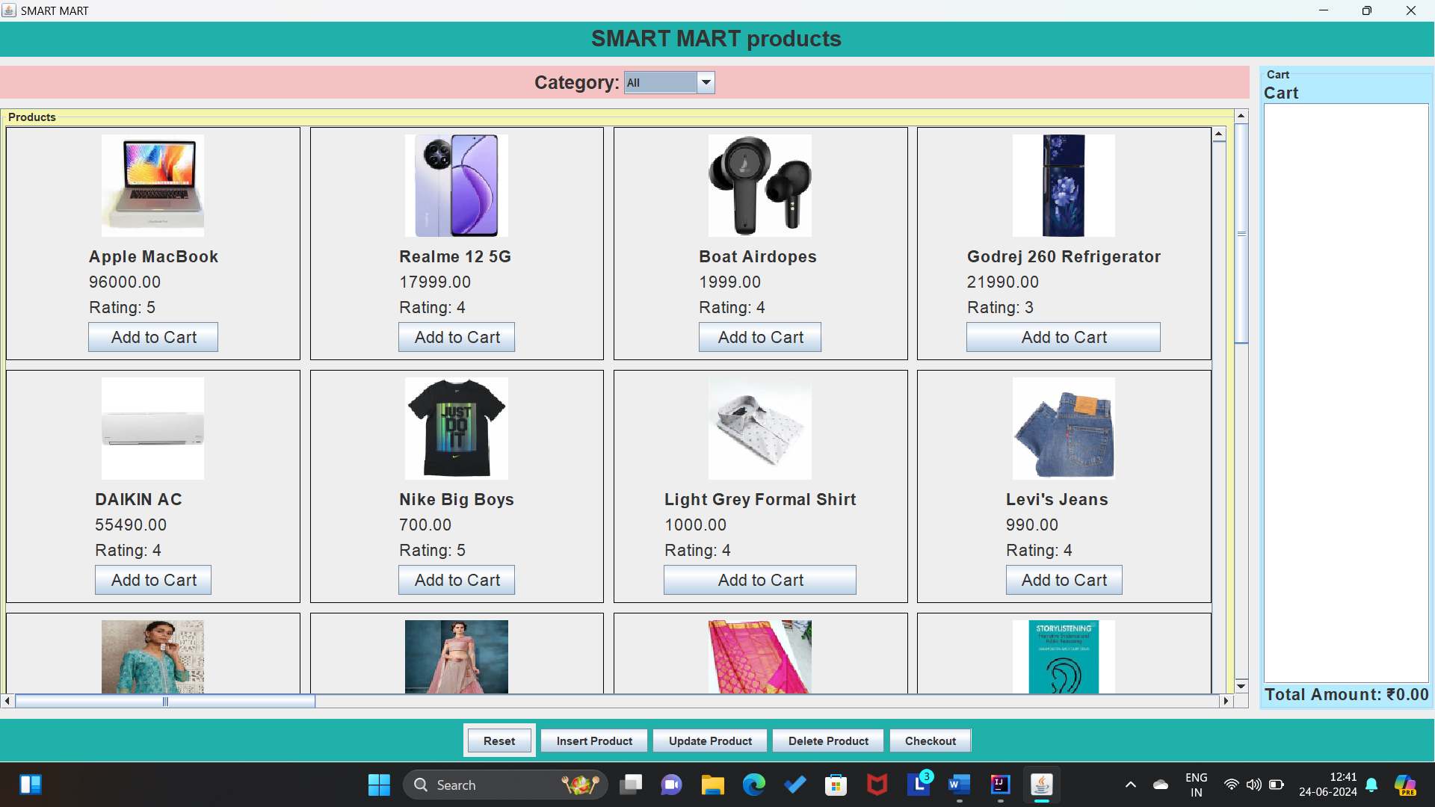

* **BillingDashboard:**

import javax.swing.*;

import javax.swing.border.EmptyBorder;

import javax.swing.text.SimpleAttributeSet;

import javax.swing.text.StyleConstants;

import javax.swing.text.StyledDocument;

import java.awt.*;

import java.awt.event.ActionEvent;

import java.awt.event.ActionListener;

public class BillingDashboard extends JFrame {

private JTextArea cartTextArea;

private double totalAmount;

private JLabel totalLabel;

private int uid; // Store uid here

public BillingDashboard(UserDashboard userDashboard) {

this.cartTextArea = userDashboard.getCartTextArea();

this.totalAmount = userDashboard.getTotalAmount();

this.uid = userDashboard.getUid(); // Fetch uid from UserDashboard

setTitle("Billing Dashboard");

setDefaultCloseOperation(JFrame.DISPOSE_ON_CLOSE);

setSize(600, 400);

setLocationRelativeTo(null);

// Custom panel to draw background image

JPanel mainPanel = new JPanel(new BorderLayout()) {

private Image backgroundImage = new ImageIcon("src/bill.jpg").getImage(); // Replace with your image path

@Override

protected void paintComponent(Graphics g) {

super.paintComponent(g);

g.drawImage(backgroundImage, 0, 0, getWidth(), getHeight(), this);

} };

mainPanel.setBorder(new EmptyBorder(0, 0, 0, 0)); // Remove padding

JLabel titleLabel = new JLabel("Billing Summary");// Header panel with title

titleLabel.setFont(new Font("Arial", Font.BOLD, 24)); // Larger font for title

titleLabel.setForeground(Color.WHITE); // Set text color to white

titleLabel.setHorizontalAlignment(SwingConstants.CENTER);

mainPanel.add(titleLabel, BorderLayout.NORTH);

// Display area for cart items and total amount

JTextPane displayArea = new JTextPane();

displayArea.setEditable(false);

displayArea.setFont(new Font("Arial", Font.PLAIN, 16));

displayArea.setForeground(Color.WHITE); // Set text color to black

displayArea.setOpaque(false); // Make text pane transparent

// Set the background color only for the text content

displayArea.setBackground(new Color(0, 0, 0, 0)); // Transparent background

// Center the text

StyledDocument doc = displayArea.getStyledDocument();

SimpleAttributeSet center = new SimpleAttributeSet();

StyleConstants.setAlignment(center, StyleConstants.ALIGN_CENTER);

doc.setParagraphAttributes(0, doc.getLength(), center, false);

// Set the text with a white background for the text content

displayArea.setText("Items in Cart:\n\n" + cartTextArea.getText() + "\n\nTotal Amount: ₹" + String.format("%.2f", totalAmount));

JScrollPane scrollPane = new JScrollPane(displayArea);

scrollPane.setPreferredSize(new Dimension(500, 200)); // Adjust dimensions as needed

scrollPane.setOpaque(false);

scrollPane.getViewport().setOpaque(false);

mainPanel.add(scrollPane, BorderLayout.CENTER);

// Total amount label at the bottom

totalLabel = new JLabel("Total Amount: ₹" + String.format("%.2f", totalAmount));

totalLabel.setFont(new Font("Arial", Font.BOLD, 18)); // Larger font for total amount

totalLabel.setForeground(Color.WHITE); // Set text color to white

totalLabel.setHorizontalAlignment(SwingConstants.RIGHT);

JPanel totalPanel = new JPanel(new BorderLayout());

totalPanel.setOpaque(false);

totalPanel.add(totalLabel, BorderLayout.EAST);

mainPanel.add(totalPanel, BorderLayout.SOUTH);

// Proceed to Payment button

JButton proceedToPaymentButton = new JButton("Proceed to Payment");

proceedToPaymentButton.addActionListener(new ActionListener() {

@Override

public void actionPerformed(ActionEvent e) {

JOptionPane.showMessageDialog(BillingDashboard.this, "Select Payment Option");

// Get cart items text and address from displayArea and addressTextField

String cartItemsText = displayArea.getText().substring(displayArea.getText().indexOf("Items in Cart:") + "Items in Cart:".length());

String address = JOptionPane.showInputDialog(BillingDashboard.this, "Enter your address:");

// Open the PaymentOptionsFrame and pass the necessary parameters

PaymentOptionsFrame paymentOptionsFrame = new PaymentOptionsFrame(cartItemsText, totalAmount, address, uid);

paymentOptionsFrame.setVisible(true);

// Close the BillingDashboard frame

dispose();

}});

JPanel buttonPanel = new JPanel(new BorderLayout());

buttonPanel.setOpaque(false);

buttonPanel.add(proceedToPaymentButton, BorderLayout.CENTER);

mainPanel.add(buttonPanel, BorderLayout.AFTER_LAST_LINE);

// Set panel background

mainPanel.setBackground(new Color(0, 0, 0, 0)); // Transparent to show the background image

// Add main panel to the frame

add(mainPanel);

}}

**OUTPUT:**

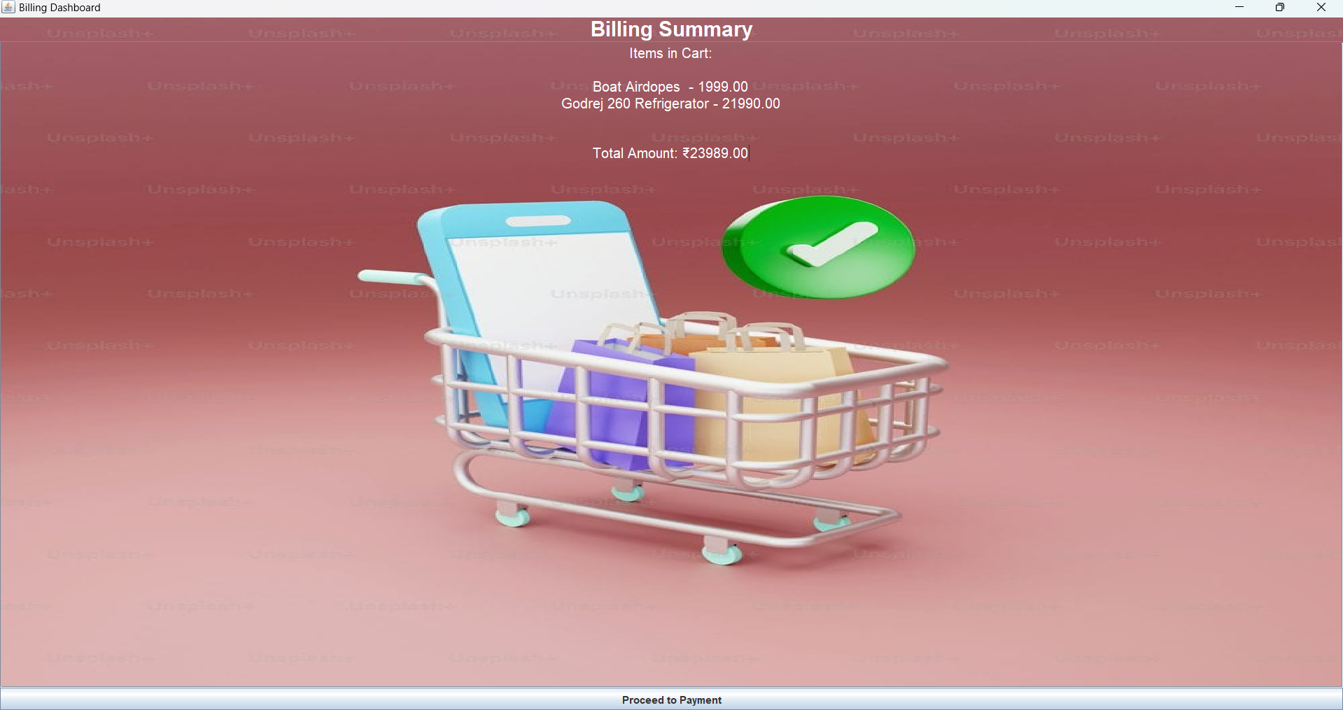

* **PaymentsOptionFrame:**

import javax.swing.*;

import java.awt.*;

import java.awt.event.ActionEvent;

import java.awt.event.ActionListener;

import java.io.BufferedWriter;

import java.io.FileWriter;

import java.io.IOException;

import java.sql.Connection;

import java.sql.DriverManager;

import java.sql.PreparedStatement;

import java.sql.ResultSet;

import java.sql.SQLException;

public class PaymentOptionsFrame extends JFrame {

private JTextField addressTextField;

private JLabel addressLabel;

private int uid; // Store uid here instead of username

private String username;

public PaymentOptionsFrame(String cartItemsText, double totalAmount, String address,int uid) {

setTitle("Payment Options");

setDefaultCloseOperation(JFrame.DISPOSE_ON_CLOSE);

setSize(400, 400);

setLocationRelativeTo(null);

JPanel mainPanel = new JPanel() {

@Override

protected void paintComponent(Graphics g) {

super.paintComponent(g);

// Load the background image

ImageIcon backgroundImage = new ImageIcon("src/pay.jpg");

// Draw the image at the panel's top-left corner

g.drawImage(backgroundImage.getImage(), 0, 0, getWidth(), getHeight(), this);

}

};

mainPanel.setLayout(new BorderLayout(10, 10));

add(mainPanel);

JPanel headerPanel = new JPanel();

headerPanel.setBackground(Color.LIGHT_GRAY);

mainPanel.add(headerPanel, BorderLayout.NORTH);

JLabel titleLabel = new JLabel("Payment Options");

titleLabel.setFont(new Font("Arial", Font.BOLD, 18));

headerPanel.add(titleLabel);

JPanel optionsPanel = new JPanel(new GridBagLayout());

optionsPanel.setOpaque(false);

optionsPanel.setBorder(BorderFactory.createTitledBorder("Payment Options"));

mainPanel.add(optionsPanel, BorderLayout.CENTER);

JRadioButton option1RadioButton = new JRadioButton("UPI");

JRadioButton option2RadioButton = new JRadioButton("Card");

JRadioButton option3RadioButton = new JRadioButton("Net Banking");

ButtonGroup paymentOptionsGroup = new ButtonGroup();

paymentOptionsGroup.add(option1RadioButton);

paymentOptionsGroup.add(option2RadioButton);

paymentOptionsGroup.add(option3RadioButton);

GridBagConstraints gbc = new GridBagConstraints();

gbc.gridx = 0;

gbc.gridy = 0;

gbc.anchor = GridBagConstraints.WEST;

gbc.insets = new Insets(5, 5, 5, 5);

optionsPanel.add(option1RadioButton, gbc);

gbc.gridy++;

optionsPanel.add(option2RadioButton, gbc);

gbc.gridy++;

optionsPanel.add(option3RadioButton, gbc);

addressTextField = new JTextField();

addressTextField.setPreferredSize(new Dimension(300, 50)); // Set preferred size

addressLabel = new JLabel("Address");

gbc.gridy++;

optionsPanel.add(addressLabel, gbc);

gbc.gridy++;

optionsPanel.add(addressTextField, gbc);

JPanel buttonPanel = new JPanel(new FlowLayout(FlowLayout.RIGHT));

JButton proceedButton = new JButton("Proceed");

proceedButton.addActionListener(new ActionListener() {

@Override

public void actionPerformed(ActionEvent e) {

String selectedOption = "";

if (option1RadioButton.isSelected()) {

selectedOption = "UPI";

} else if (option2RadioButton.isSelected()) {

selectedOption = "Card";

} else if (option3RadioButton.isSelected()) {

selectedOption = "Net Banking";

} else {

JOptionPane.showMessageDialog(PaymentOptionsFrame.this, "Please select a payment option.");

return;

}

String address = addressTextField.getText();

if (address.isEmpty()) {

JOptionPane.showMessageDialog(PaymentOptionsFrame.this, "Please enter an address.");

return;

}

double amount = totalAmount; // Assuming totalAmount is accessible here

insertPayment(uid, selectedOption, amount);

JOptionPane.showMessageDialog(PaymentOptionsFrame.this, "Selected Option: " + selectedOption);

JOptionPane.showMessageDialog(PaymentOptionsFrame.this, "Payment Successful\nSave the Receipt");

generateReceipt(cartItemsText, totalAmount, address);

JOptionPane.showMessageDialog(PaymentOptionsFrame.this, "Receipt Downloaded\nVisit again");

dispose();

UserDashboard userDashboard = new UserDashboard(uid);

userDashboard.setVisible(true);

}

});

buttonPanel.add(proceedButton);

mainPanel.add(buttonPanel, BorderLayout.SOUTH);

// Retrieve uid based on username

//this.uid = retrieveUid();

}

private int retrieveUid(String username) {

int uid = -1;

try (Connection connection = DriverManager.getConnection(

"jdbc:mysql://127.0.0.1:3306/ecommerce", "root", "suvarna")) {

String query = "SELECT rid FROM registration WHERE username = ?";

PreparedStatement ps = connection.prepareStatement(query);

ps.setString(1, username);

ResultSet rs = ps.executeQuery();

if (rs.next()) {

uid = rs.getInt("rid");

} else {

JOptionPane.showMessageDialog(this, "Username not found in registration table.", "Error", JOptionPane.ERROR_MESSAGE);

}

ps.close();

} catch (SQLException e) {

e.printStackTrace();

JOptionPane.showMessageDialog(this, "Error occurred while retrieving UID.", "Error", JOptionPane.ERROR_MESSAGE);

}

return uid;

}

private void insertPayment(int uid, String paymentMethod, double amount) {

try (Connection connection = DriverManager.getConnection(

"jdbc:mysql://127.0.0.1:3306/ecommerce", "root", "suvarna")) {

String query = "INSERT INTO payments(uid, payment_method, amount) VALUES (?, ?, ?)";

PreparedStatement ps = connection.prepareStatement(query);

ps.setInt(1, uid);

ps.setString(2, paymentMethod);

ps.setDouble(3, amount);

int rowsAffected = ps.executeUpdate();

if (rowsAffected > 0) {

System.out.println("Payment details inserted successfully.");

} else {

System.out.println("Failed to insert payment details.");

}

ps.close();

} catch (SQLException e) {

e.printStackTrace();

JOptionPane.showMessageDialog(this, "Error occurred while processing payment.", "Error", JOptionPane.ERROR_MESSAGE);

}

}

private void generateReceipt(String cartItemsText, double totalAmount, String address) {

JFileChooser fileChooser = new JFileChooser();

int userChoice = fileChooser.showSaveDialog(this);

if (userChoice == JFileChooser.APPROVE_OPTION) {

String filePath = fileChooser.getSelectedFile().getPath();

try {

BufferedWriter writer = new BufferedWriter(new FileWriter(filePath));

writer.write("Receipt\n\n");

writer.write("Items in Cart:\n\n");

writer.write(cartItemsText);

writer.write("\n\n");

writer.write("Total Amount: ₹" + totalAmount);

writer.write("\n\n");

writer.write("Address: " + address);

writer.close();

} catch (IOException e) {

e.printStackTrace();

}

}

}

}+

**OUTPUT:**

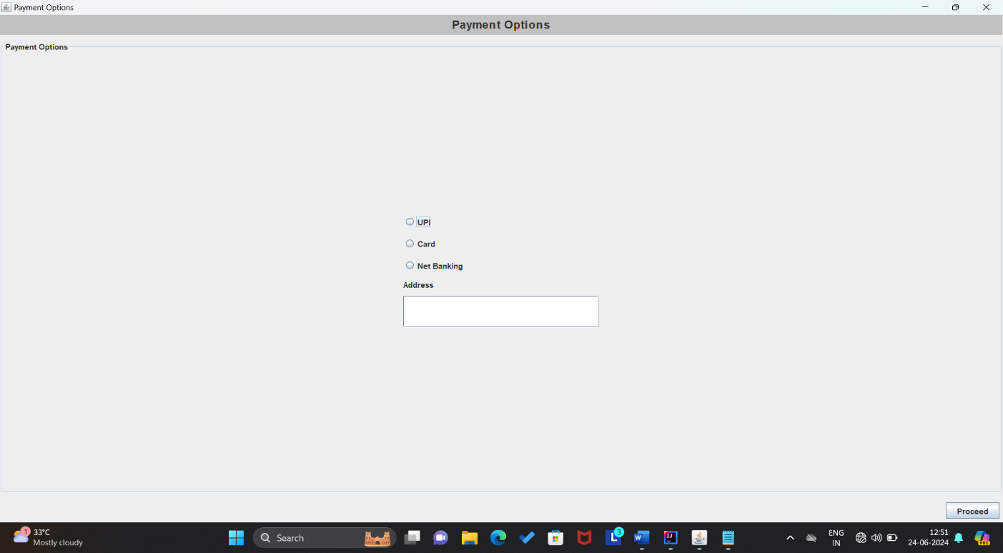

**GUI OUTPUTS:**

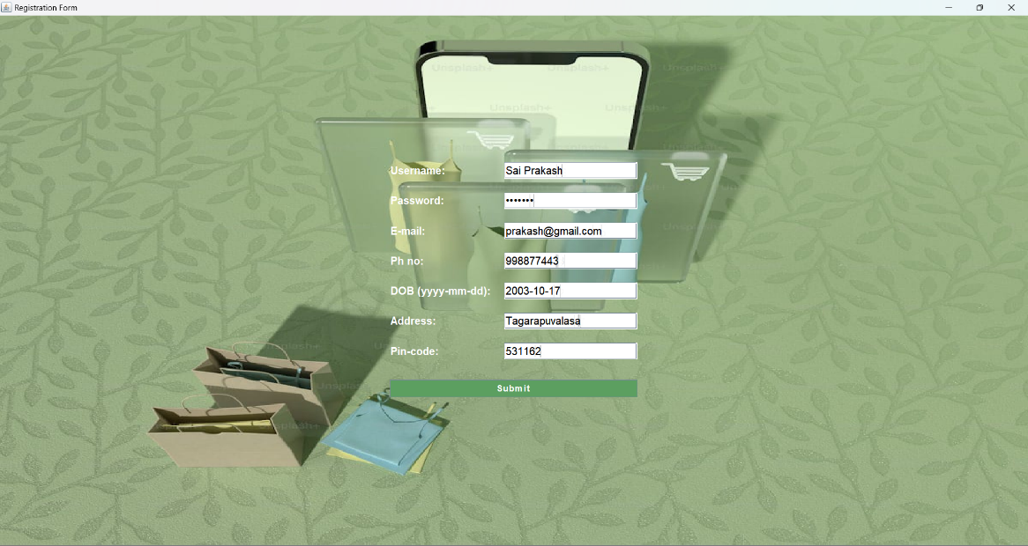

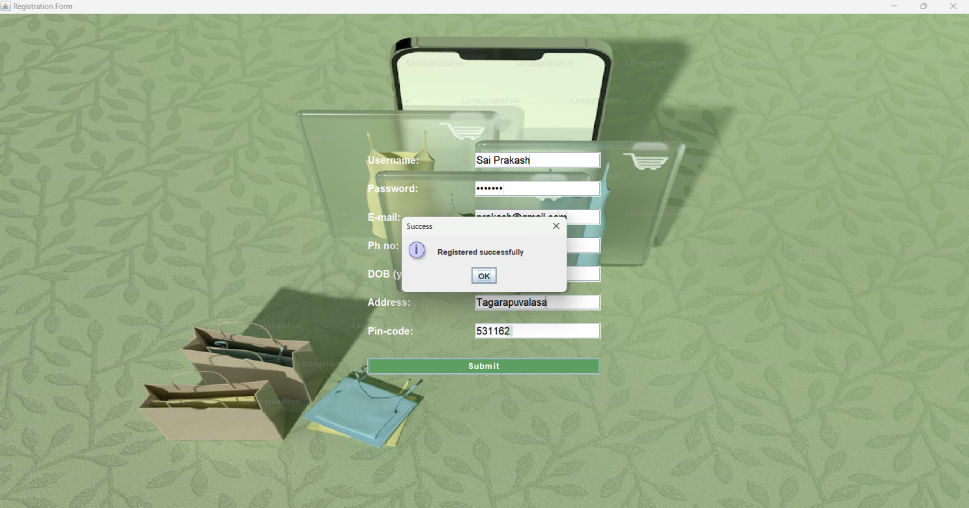

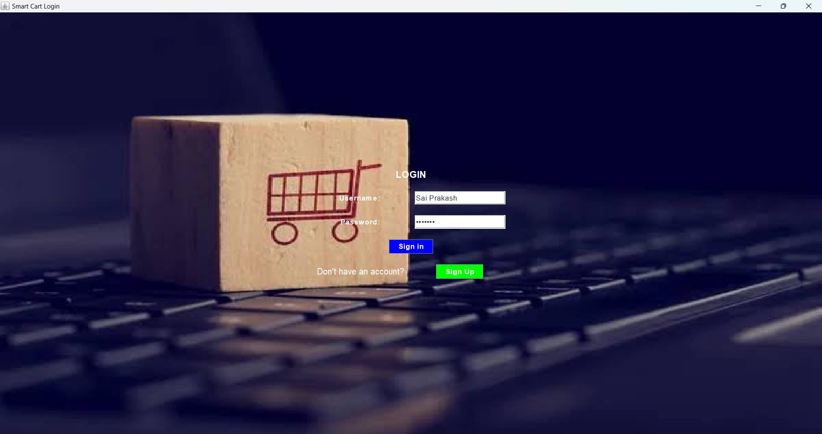

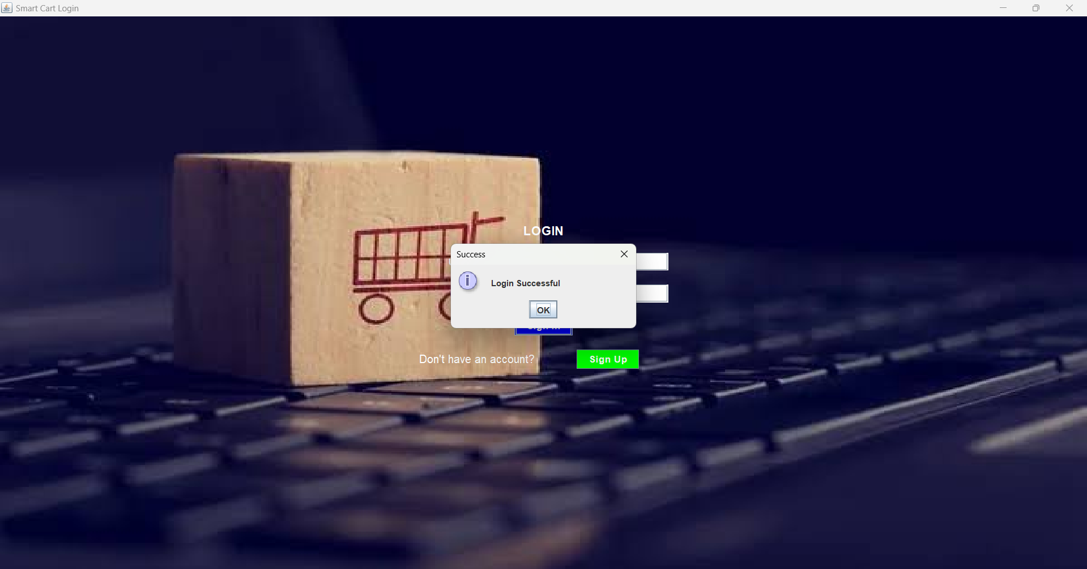

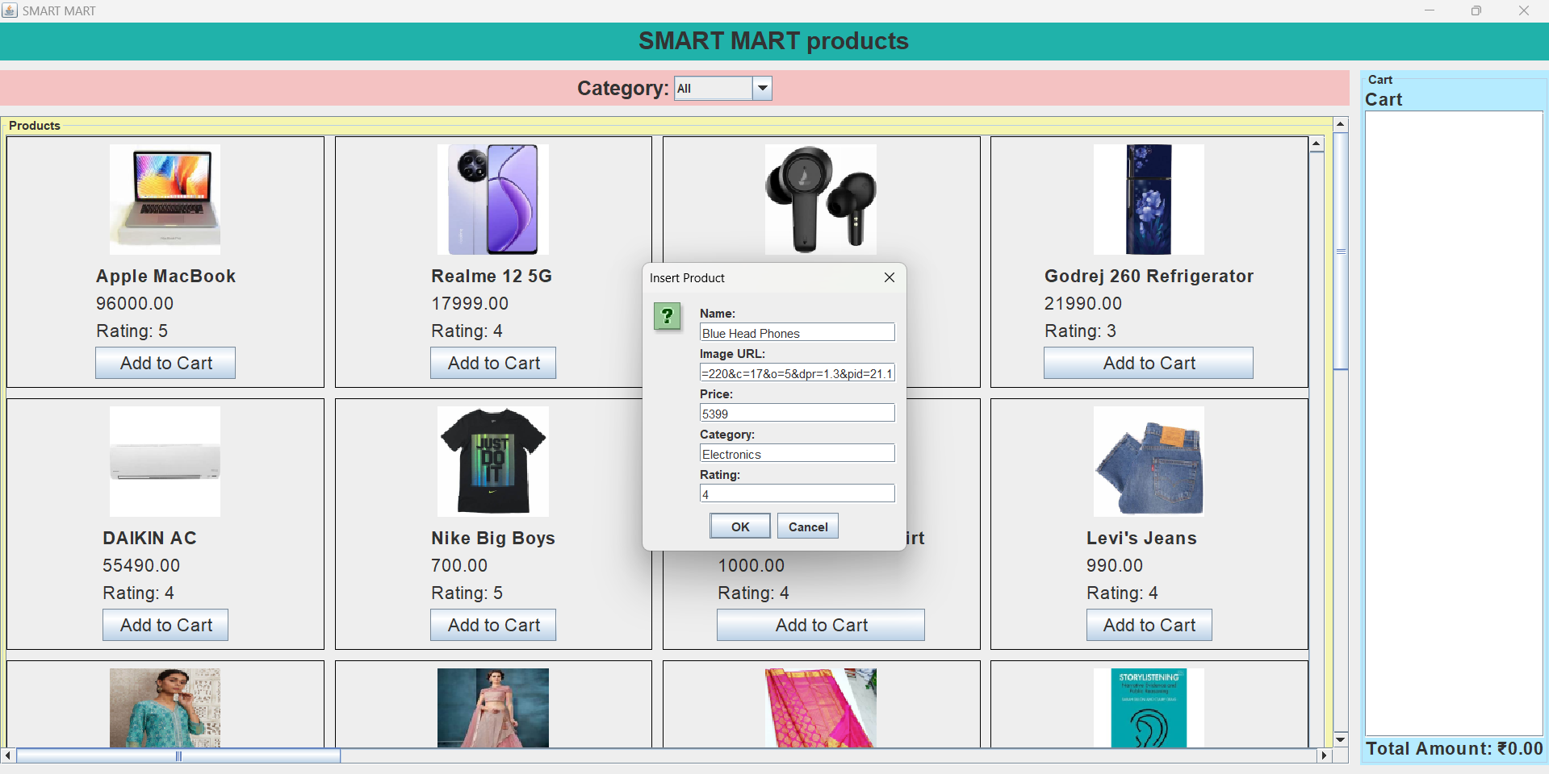

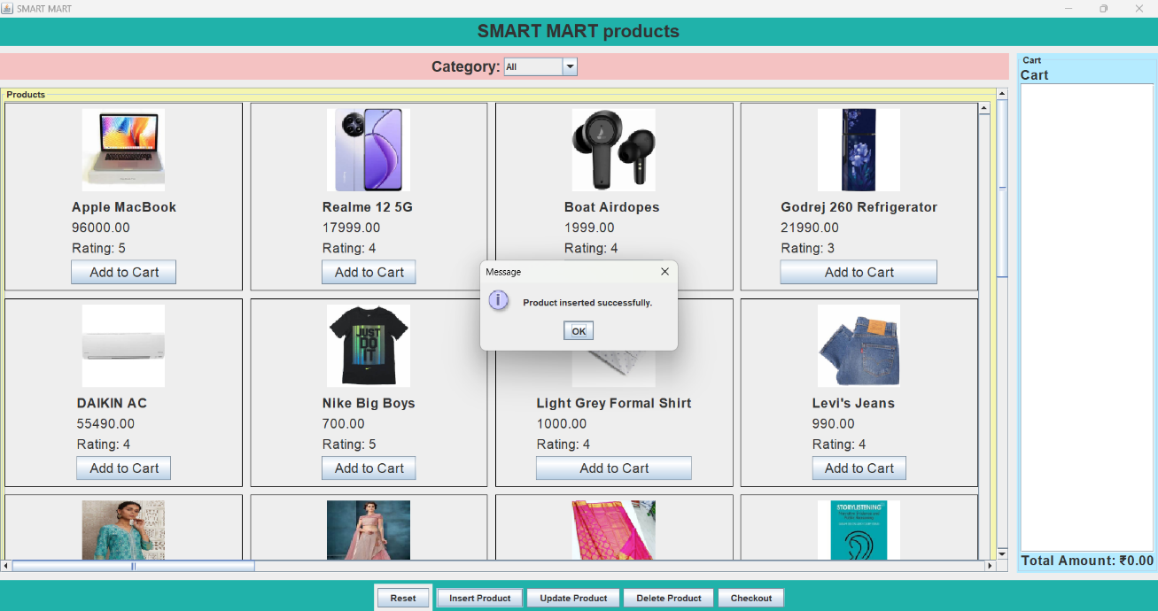

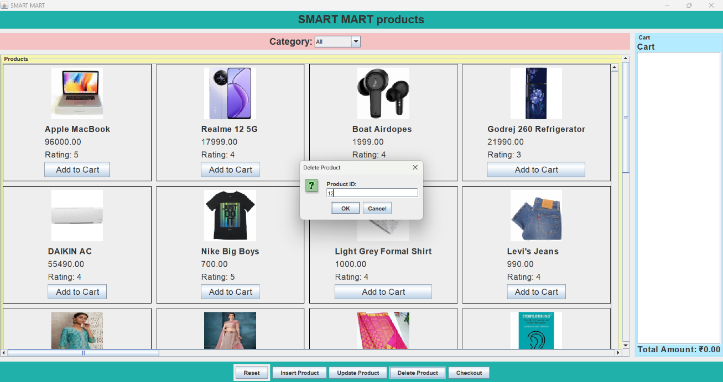

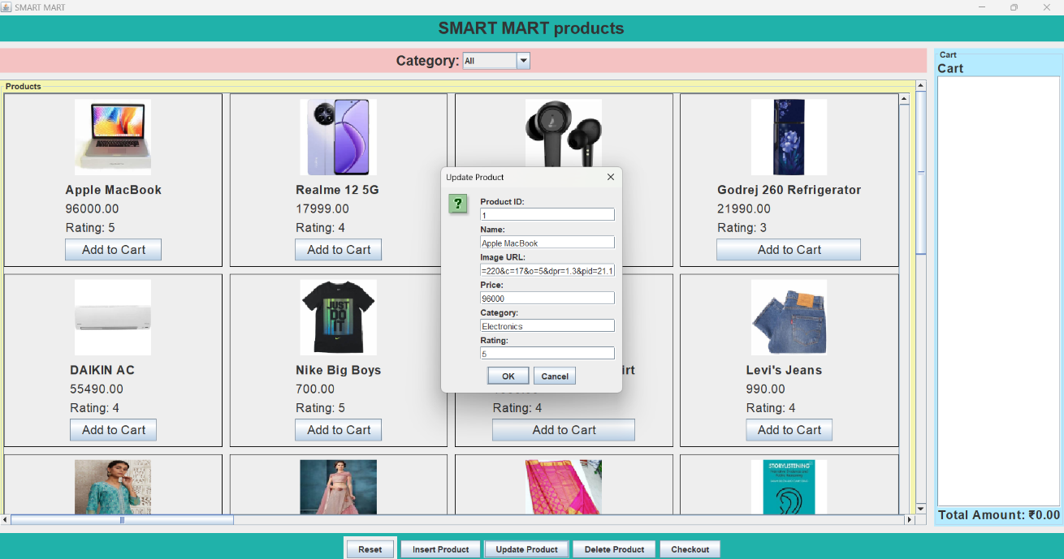

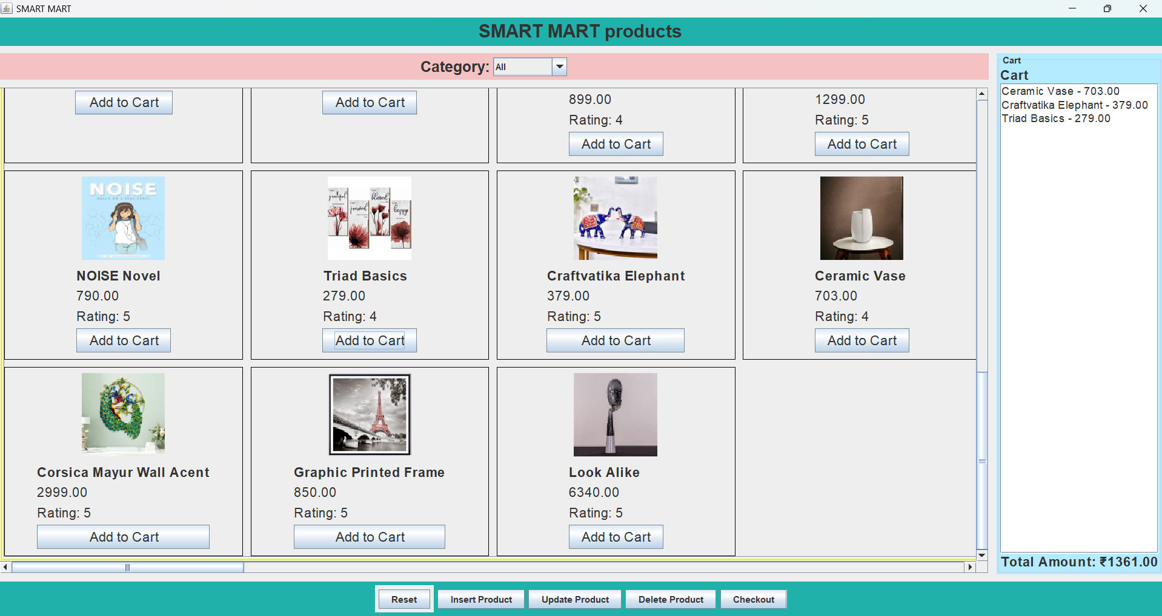

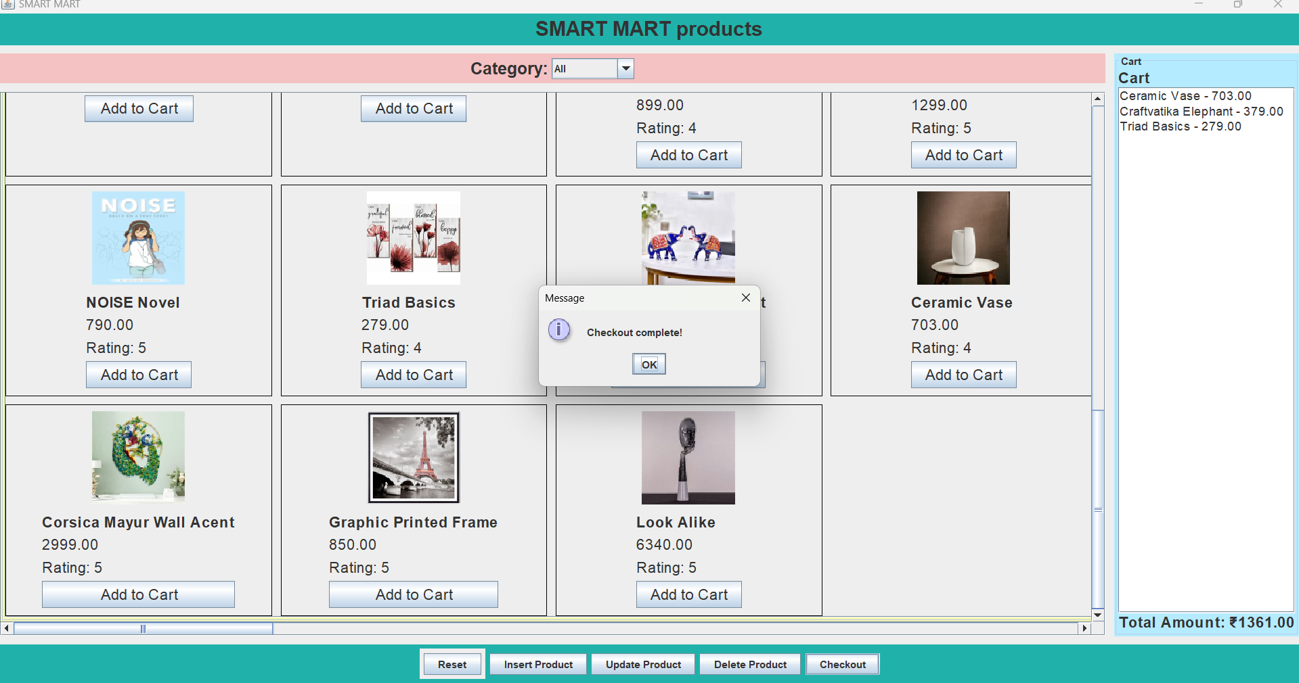

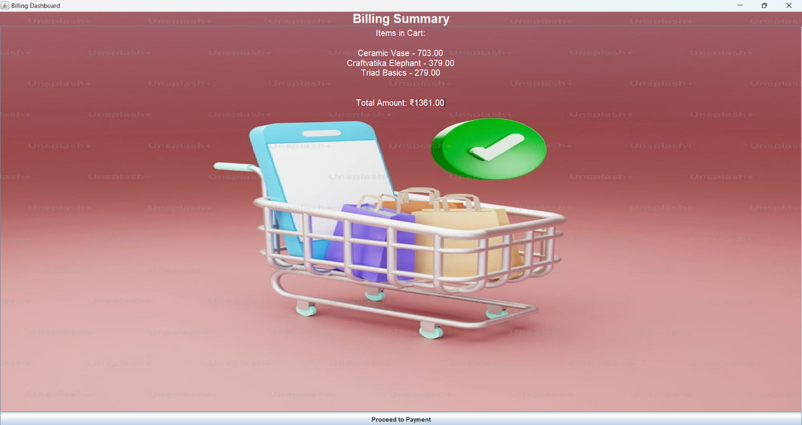

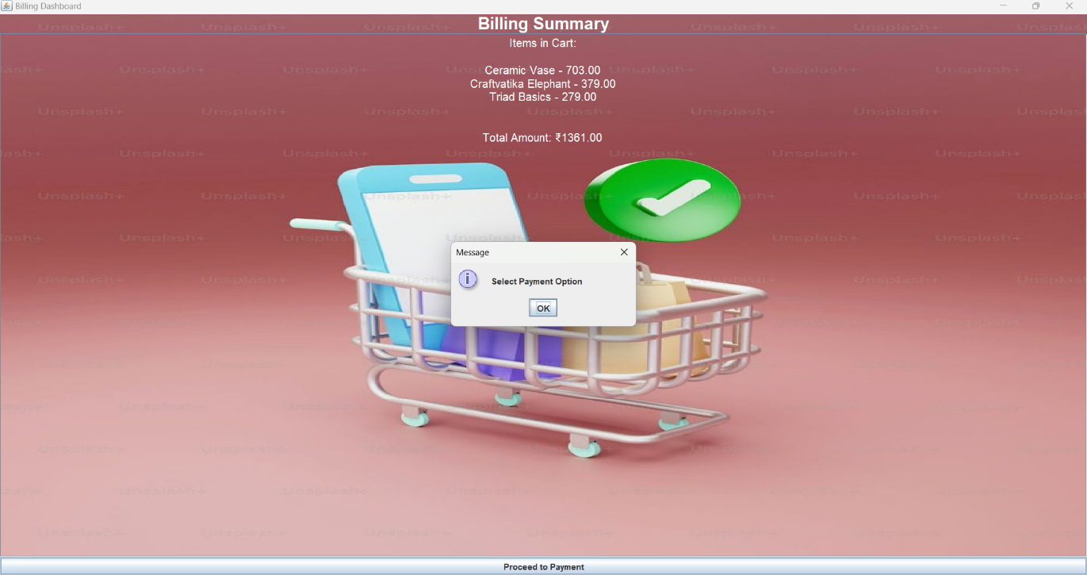

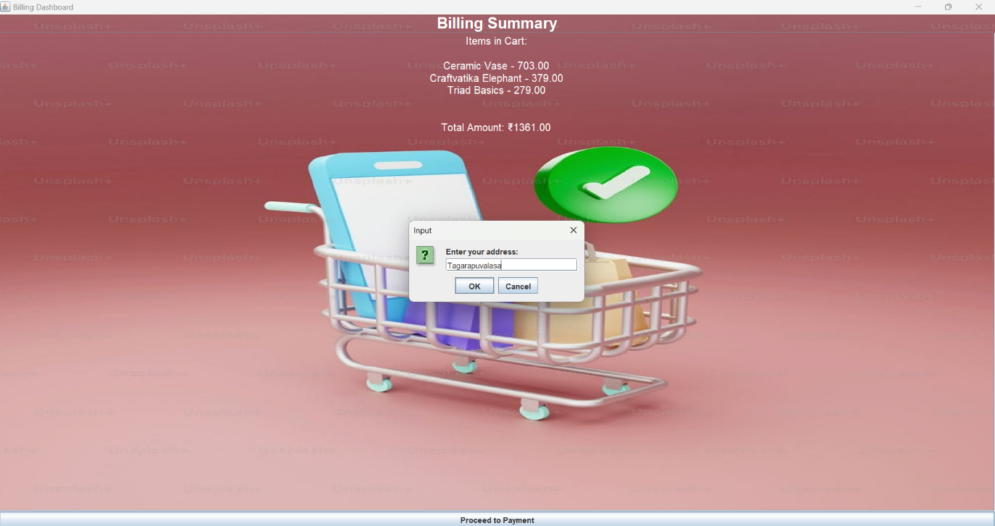

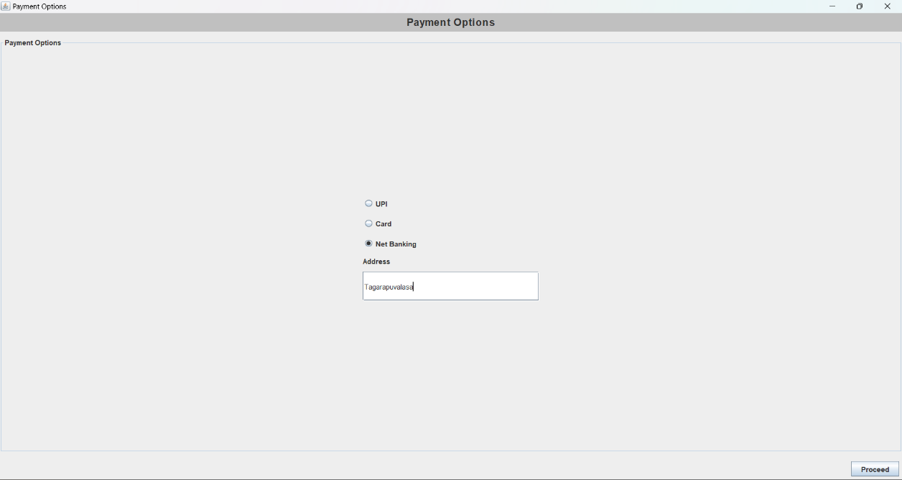

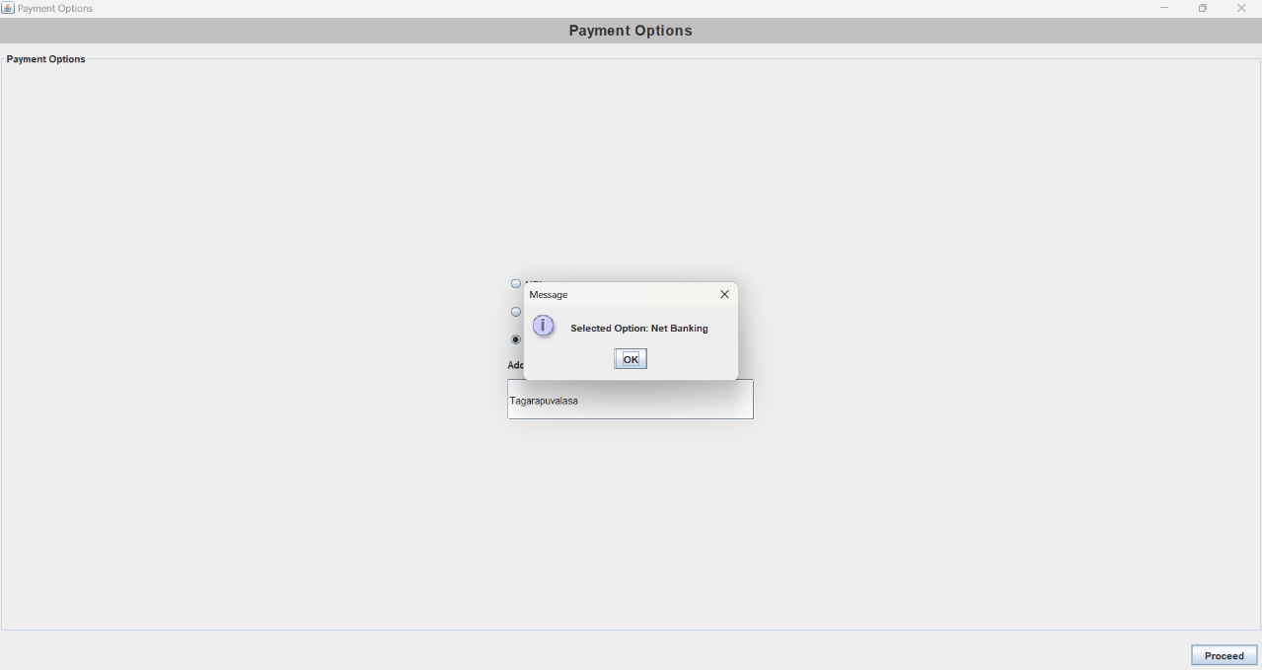

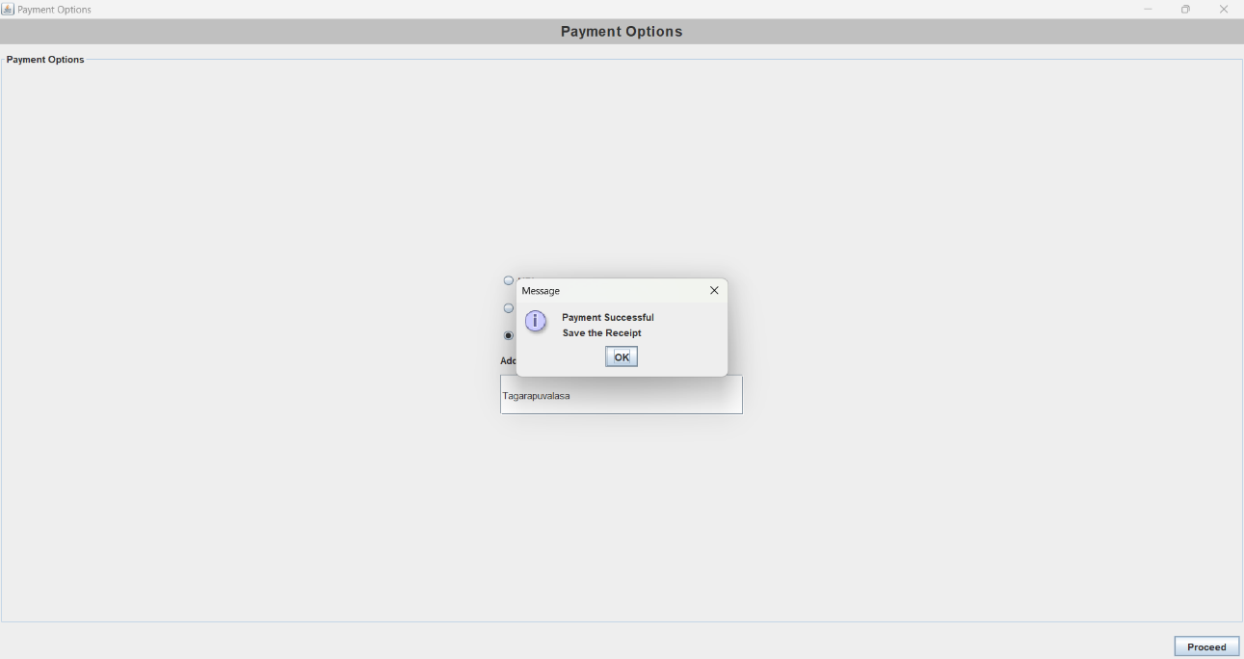

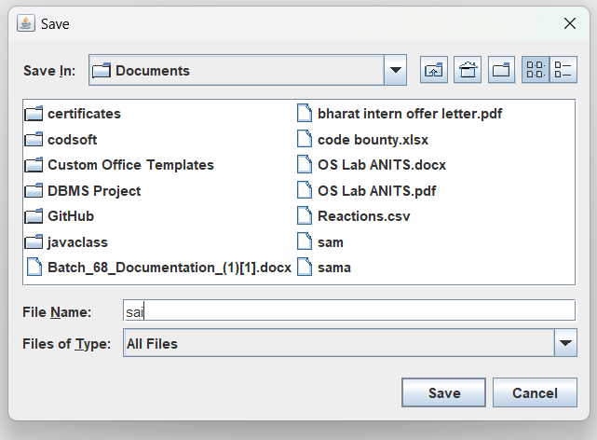 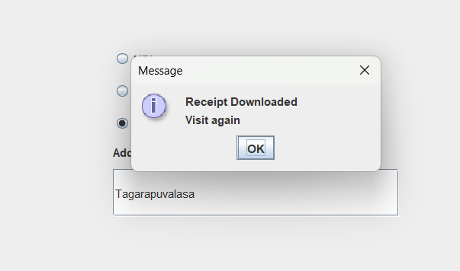

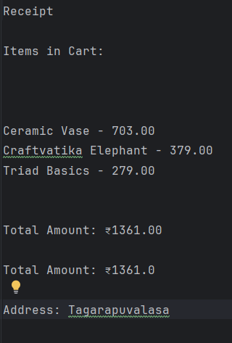

**CONCLUSION:**

In conclusion, the Java AWT-based eCommerce Platform project represents a concerted effort to leverage Java's capabilities in both GUI development and database management to create a robust online store application. By utilizing AWT for frontend development and JDBC with MySQL for backend operations, the project aims to deliver a user-friendly interface coupled with seamless database integration.

The primary goals of the project include implementing essential eCommerce functionalities such as user authentication, product management, shopping cart operations, order processing, and order history tracking. Emphasis is placed on scalability, robustness, and ensuring a smooth user experience through efficient UI design and backend operations.

Moving forward, the project intends to provide a foundation for future enhancements and increased user load by designing a scalable architecture and ensuring data integrity throughout the application. This approach not only addresses current eCommerce needs but also prepares the platform for potential future expansions and improvements.

By combining Java AWT's GUI components, JDBC's database connectivity, and MySQL's reliability as an RDBMS, the Java AWT-based eCommerce Platform project aims to fulfill its objectives of creating an interactive, efficient, and scalable online shopping experience.